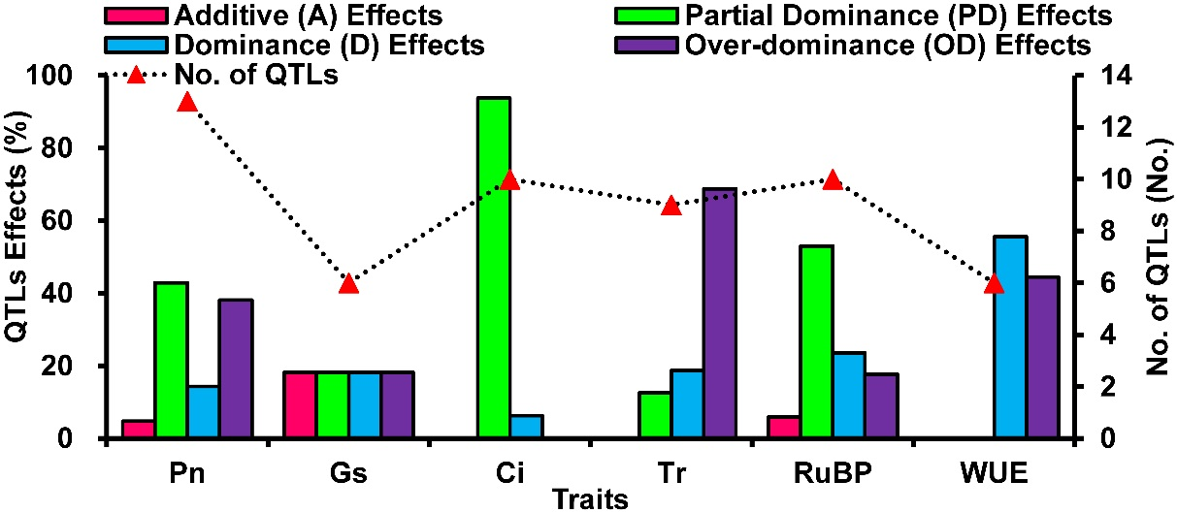
Additional file 5: Fig. S3 Summary of identified QTLs for photosynthetic-related traits (Pn net photosynthetic rate, Gs stomatal conductance, Ci intercellular CO₂ concentration, Tr transpiration rate, RuBP ribulose 1,5-biphospate carboxylase activity, WUE water use efficiency) in two F₄ populations (POP-CT and POP-LT) by single environment mapping with composite interval mapping (CIM). Including No. of QTLs and QTLs effects (A, additive effect; PD, partial dominance effect; D, dominance effect; OD, over-dominance effect), respectively

